Media Inquiries, contact:
Regina Marston
Plan A Public Relations & Marketing, Inc.
regina@planpr.com
Tel: +1 (321) 231-9353

FOR IMMEDIATE RELEASE

AAB Smart Tools Continues the Innovation Revolution
in the HVAC Industry with the Wireless ABM-200

The game-changing ABM-200 debuts as the HVAC industry’s first wireless airflow and environmental meter for use with smartphones and devices.

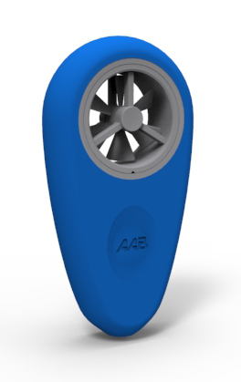
Orlando, FL – July , 2015 – AAB Smart Tools (AAB), an Orlando-based company, is quickly being recognized as the leader of the innovation revolution in the HVAC industry with the introduction of smartphone tools that are accurate, affordable and easy to use. After the success of its ABM-100, the HVAC industry’s first smartphone anemometer, the company now introduces the next generation of the meter, the ABM-200. This revolutionary product offers all the features of the ABM-100, plus temperature, humidity and pressure sensors. It also incorporates Bluetooth Smart technology to work wirelessly with smartphones and other devices, making it the HVAC industry’s first wireless airflow and environmental meter.
The ABM-200 is designed to assist HVAC technicians in assessing the health of a system, safely and efficiently, by easily allowing the technician to measure and record a variety of data including:

- Airflow Velocity
- Airflow Volume
- Dry Bulb Temperature
- Wet Bulb Temperature
- Relative Humidity
- Feels Like Temperature
- Dew Point
- Air Density
- Wind Speed/Direction/Gusts
- Indoor vs. Outdoor Conditions
- Barometric Pressure

-more-

The ABM-200 utilizes Bluetooth Smart technology to connect seamlessly and quickly to smartphones and tablets. Bluetooth Smart connects over 20 times faster than classic Bluetooth devices and uses a fraction of battery power. The meter features a ruggedized housing with a ¼ inch-20 UNC fitting for mounting to various accessories, which allows for hands free operation. It also comes in an ergonomic carrying case that easily fits into a technician’s pocket or tool bag.

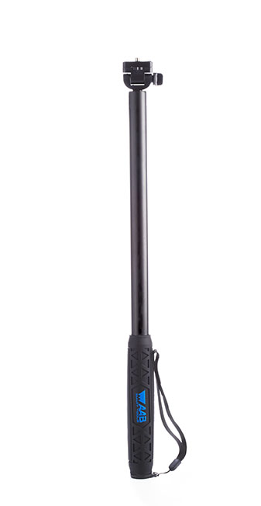
The ABM-200 also enhances the technician’s professionalism with its free app, which is complete with onscreen guidance on how to use the device to ensure accuracy. The app generates a personalized report that can be emailed immediately to the client or home office. In addition, to ensure safety and enhance productivity, the ABM-200 can be attached to the AAB EXP-64, a 64” rugged extension pole (sold separately) to take readings without having to use a ladder.

“After the success of the ABM-100, we knew we were on to something revolutionary,” said Scott Madden, Vice President of Product Development for AAB Smart Tools. “We worked closely with our engineering team to take our product to the next level and provide the HVAC industry with a tool that would bring even more benefits to technicians to help them work smarter, not harder. The ABM-200 is an incredible tool that will enhance productivity, ensure safety, and promote a high level of professionalism for the technicians who use it.”

AAB Smart Tools is actively developing numerous additional smart tools to serve the HVAC industry and plans to introduce several more innovative products in 2015.
For more information, please visit www.AABsmart.com
About AAB Smart Tools | AAB Smart Tools (AAB) designs and manufactures smartphone tools that simplify and improve the analysis of HVAC systems. With headquarters in Orlando, Florida, the company’s focus is to manufacture HVAC industry specific smart tools that are accurate, affordable, and easy to use. By providing tools with easy-to-follow onscreen guidance and ergonomic designs, AAB Smart Tools has made the application and understanding of building sciences practical for all levels of HVAC professionals. For more information, please visit www.aabsmart.com or contact info@aabsmart.com.

###

